**ARCHITECTURE AND DESIGN DOCUMENT FOR COVID-19 Tracker**

The COVID-19 patient tracker is an android application that uses data stored in the databases on the cloud and keeps track of the details of the COVID-19 infected person.

**Architecture**

The Overall structure of the system is shown in figure below. As per the structure, the User logins to the Android application.

The structure of the system says COVID application starts with user login. As user is logged in to the system of COVID application, two screens appear one is the Area wise tracking another is Take a Quick survey.

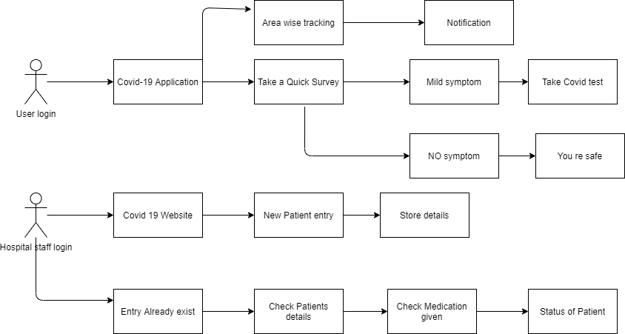

1. **Area wise Tracking: -** Area wise tracking contains the list of areas with the updated list of COVID-19 patients. The list of patient’s details is updated every day in an interval of 24 hours after the COVID-19 details is updated in to the hospital. As soon as the COVID-19 patients report comes out to be positive, the list is updated in to the hospital database and after every 24 hours the complete list is updated into the cloud database.
2. **Take a Quick Survey: -** The User logs in to the application, once the user enters its details to the application, the person is asked to take a quick survey. This survey consists of some questionnaire that is related to the COVID-19 symptoms like; 1. Do you have cold and cough? 2. Do you feel dizziness? 3. Do you have fever? Etc.
3. **Notification: -** Notification is the feature that notifies user about the number of cases in the nearby locality. For example; In 1-mile range how many people are infected, in 2-mile range how many people are infected. For this thing first of all the application detects the location of the user, once the location is detected it will access the database and recover the details about the COVID-19 infected people in the nearby locality. Then it notifies the user about the number of infected persons.
4. **Mild Symptom: -** Once the user completes the survey and gives answer to the questionnaire, it will detect the user is infected or have a mild symptom or not infected at all. Once the questionnaire is solved, it will help the user to detect that you have mild symptoms or you can say the user is asymptomatic.
5. **Take COVID-19 Test: -** If the user is found asymptomatic then the application suggests that you should take the COVID-19 test. It will suggest the user to go for a COVID-19 test centre and also provides the list of COVID-19 centres in the nearby area.
6. **No Symptoms: -** If the user has no symptoms after taking the test then it will notify on the screen that you have no symptoms of COVID-19.
7. **You re safe: -** If the user is detected with no symptoms, then once the test is completed and the user has no symptoms then it prints “You re safe”. It indicates that you are totally safe and gives a green dot to the mobile number as it’s a COVID-19 safe user.

Hospital Staff Login (This part is just for updating the database)

1. **Hospital staff login: -** Hospital staff logs in to the website of COVID-19. Once the patient is detected COVID-19 positive, his/her information is entered into the database of COVID-19 database on the cloud. As it will help to detect the number of users infected in the areas of the country. Each and every COVID-19 hospital has given access to the database to update the details of patient who is detected COVID-19 positive.
2. **COVID-19 Website: -** This website is used by all the COVID-19 hospitals to update the details of COVID-19 patients. This website access is there for all the hospitals once a user is found COVID-19 positive, the database is updated. It will help to detect the number of COVID-19 infected people around us.
3. **New Patient entry: -** As some person feels infected or thought like mild symptoms then he can go to hospital for COVID-19 test. Once the sample is taken for COVID-19 test, his details are entered into the database. Then when the report comes and notifies if the patient is COVID-19 positive or COVID-19 negative, the details are stored into the database. After that all the details of patient are recorded into the database.
4. **Store details: -** All the details of person are stored in the database who come for the COVID-19 test. Initially the details are stored in the hospital’s database then after every 24 hours these details are updated on the cloud for universal access.
5. **Entry Already Exist:** - When the hospital user logs in to the system and enters the details about the patient in the database and if the entry of the person already exists in the database then it notifies the entry already exist. The possibility of this feature comes into the picture as if the person has mild symptoms and has already gone through the COVID-19 test once, then his entry is updated accordingly. Sometimes the people get COVID-19 infection twice or may be thrice or may be more than that.
6. **Check Patients details: -** If any of the hospital staff wants to check the details of patient then they can check through this feature.
7. **Check Medication given: -** This feature stores the medication given to the patient’s day wise so that the tracking of recovery details of patient can be checked when required.
8. **Status of Patient: -** The status of the patient is recorded in the database whether he is COVID-19 positive or not. If he is detected COVID-19 positive then after that it will keep track that after how many days his reports are tested negative. All the details help to record the status of the patient.

• Identify risks:

1. **People: -** The main risk is due to people who are unaware about the symptoms of COVID-19. If a person is asymptomatic and he is unaware about the COVID-19 symptoms but he is infected then he can spread it to many people. Calculating the exact number of infected people is difficult and it can lead to misconception.
2. **Data: -** If the COVID-19 patients detailed data is stored wrongly then the whole calculation of infected people become mismanaged. There are some hospitals provided with login ID for COVID-19 database updating but some small hospitals don’t have data updating authority who are also operating COVID-19 patients with mild symptoms so detecting their data becomes very difficult.
3. **Be Agile:** - The questionnaire stored in the application should be updated on the frequent interval so that the new symptoms detected with time is also checked for detection of COVID-19.
4. **Security: -** The application stores data of N number of users and also database access is given to many hospital staff. In this case security of patient’s data is at a higher risk. Whenever a user login to the application and stores his information, the data should be passed on through the cloud service provider encryption APIs. These APIs will encrypt the data and then it is stored in the database.

• User Interface.

**Basic User interface: -** The user interface for this application starts with the initial screen that displays a message like “Welcome to the COVID-19 Application”. Then you will be asked to click on next.

**After next:** - Two options will be displayed 1. Area wise Tracking.

2**.** Take a quick survey

**Design Documentation**

• Audience: The Audience of the system is the

1. **User –** The user accesses the mobile application for detecting the number of patients in the locality and checking itself the status of COVID-19 administrator- The Administrator manages all the activity of the system.
2. **Hospitals Staff –** Hospital staff can enter and update the details of COVID-19 patient.

• Elaboration of the architecture.

